Class 3rd

MATHEMATICS

WEEK – 1

● Write and learn table of 2 and 5.

● Write number name of 1 to 100.

● Make a balance to measure weight .

WEEK – 2

● Write and learn table of 6 and 10.

● Observe different rupees note (10,20,50 ) and write the following details

a) Number of languages

b) Identify pictures and symbols given

● Practice and write five each 2-digit addition and 3- digit addition.

WEEK – 3

● Write and learn table of 11 and 12.

● Use different mathematical shapes (triangle, rectangle, square, oval, etc. and make 2

different pictures and color it.

WEEK – 4

● Write and learn table of 13 and 14.

● Make a rangoli design using dots grid.

WEEK – 5

● Write and learn table of 15.

● Make 5 modal each of shape like CIRCLE, SQUARE, RECTANGLE, DIAMOND.

Class 3rd (Hindi)

प्रश्न १. 20 पेज सुलेख लिखे |

प्रश्न २ . शेखीबाज मक्खी कहानी मे से किसी एक पात्र का मुखोटा बनाये |

प्रश्न ३. 10 विलोम शब्द व 10 पर्यायवाची शब्द लिखिए|

प्रश्न ४ . रोज एक सुविचार लिखिए ( दिनांक सहित )|

प्रश्न ५ . संज्ञा , सर्वनाम व क्रिया विशेषण की परिभाषा

और 10-10 उदहारण लिखिए |

प्रश्न ६ . मन से सोच कर किसी कविता या कहानी का निर्माण करे व उत्तरपुस्तिका मे लिखे | ( 250 शब्दों मे )

**SUBJECT-EVS**

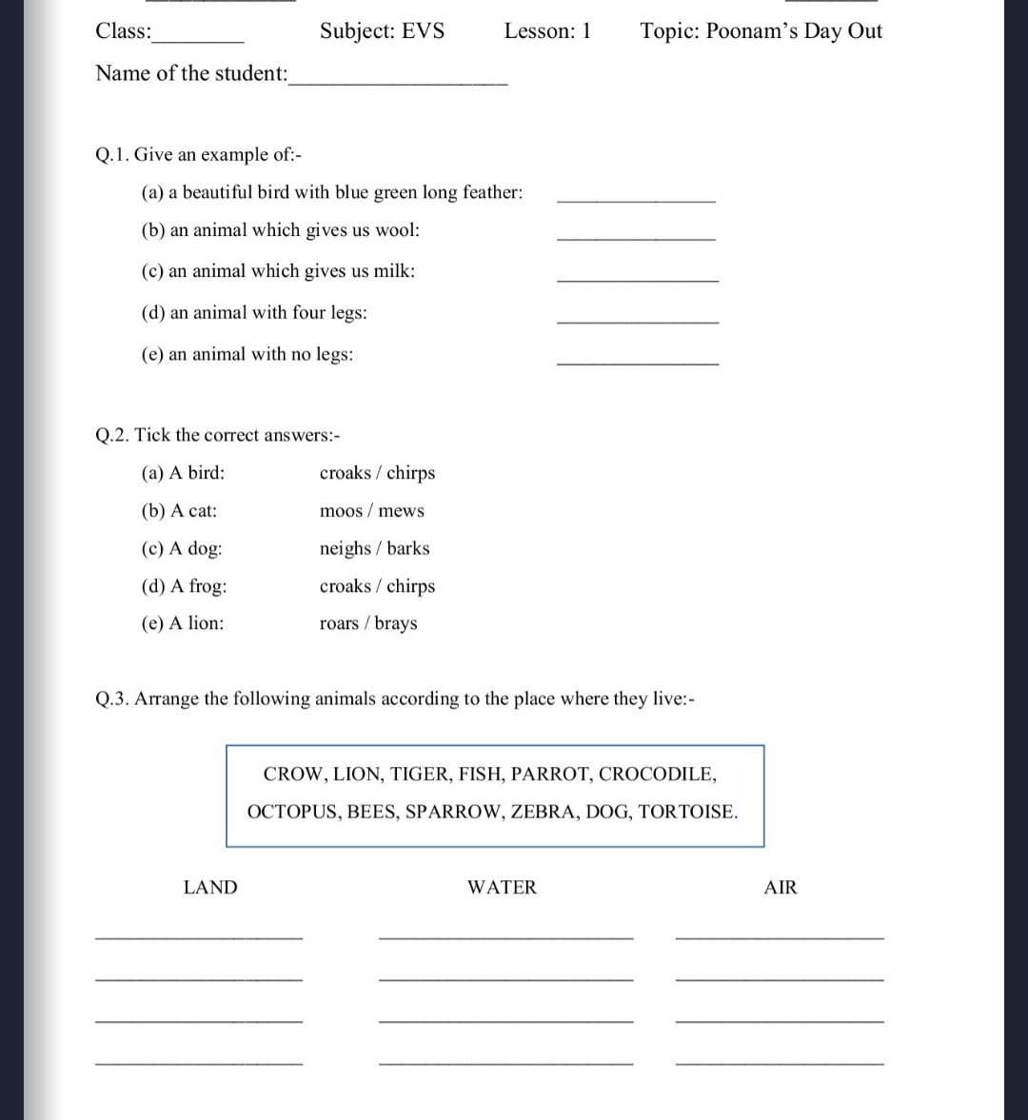

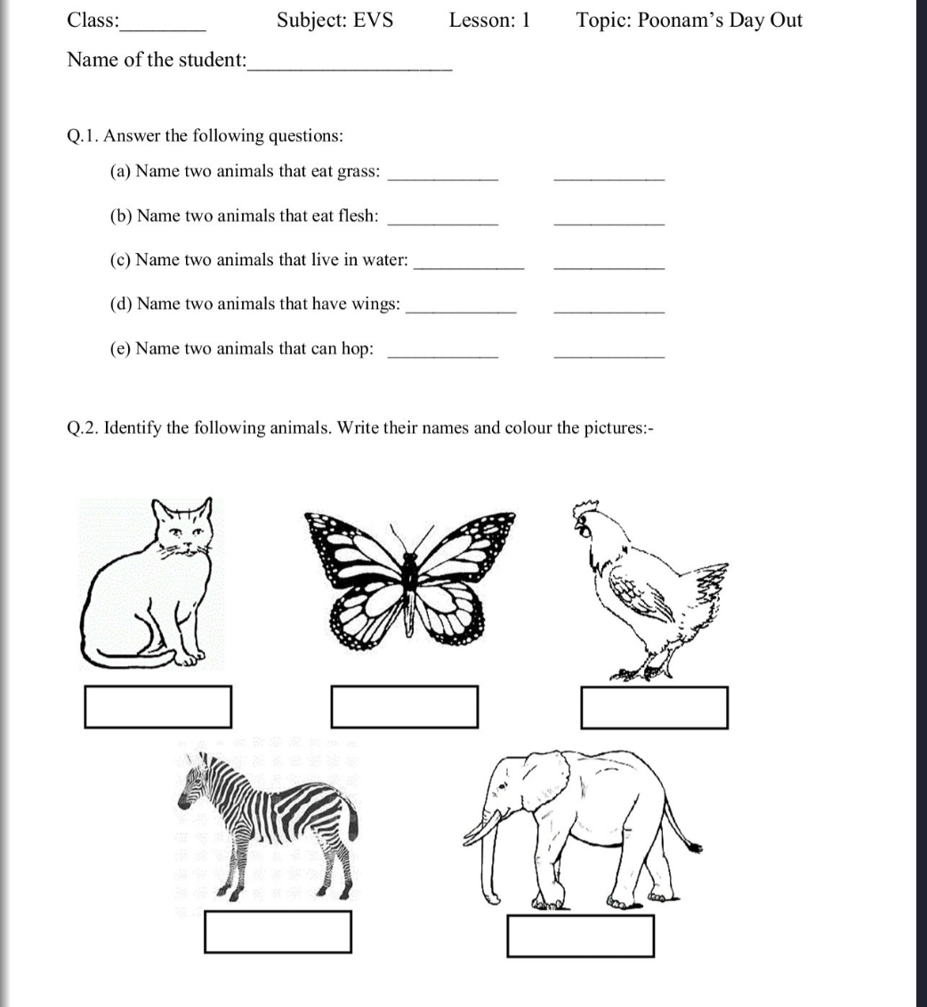

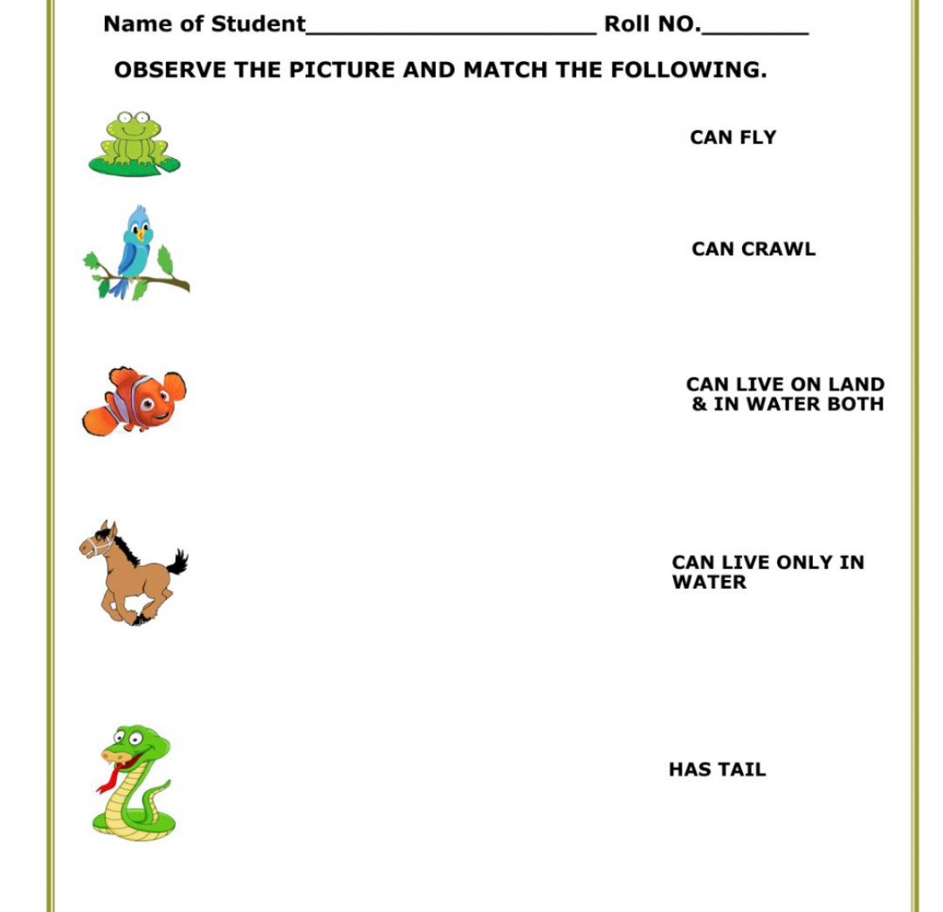

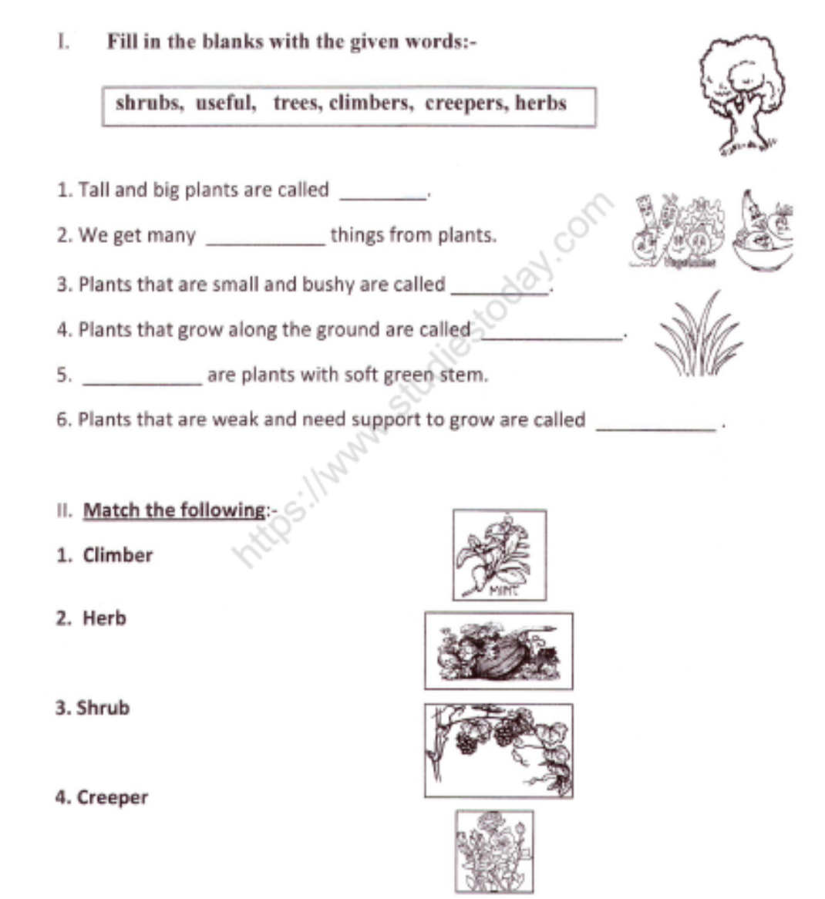

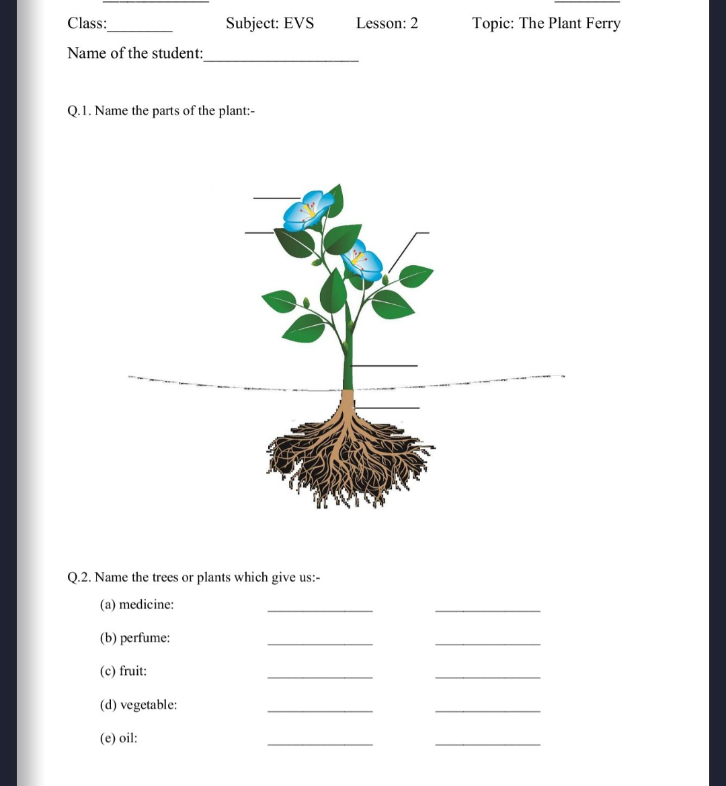

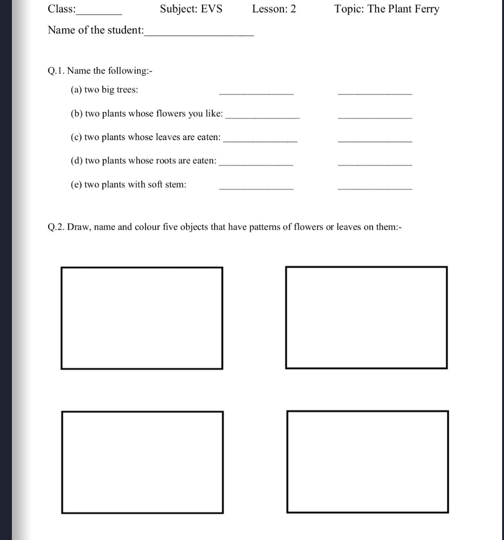

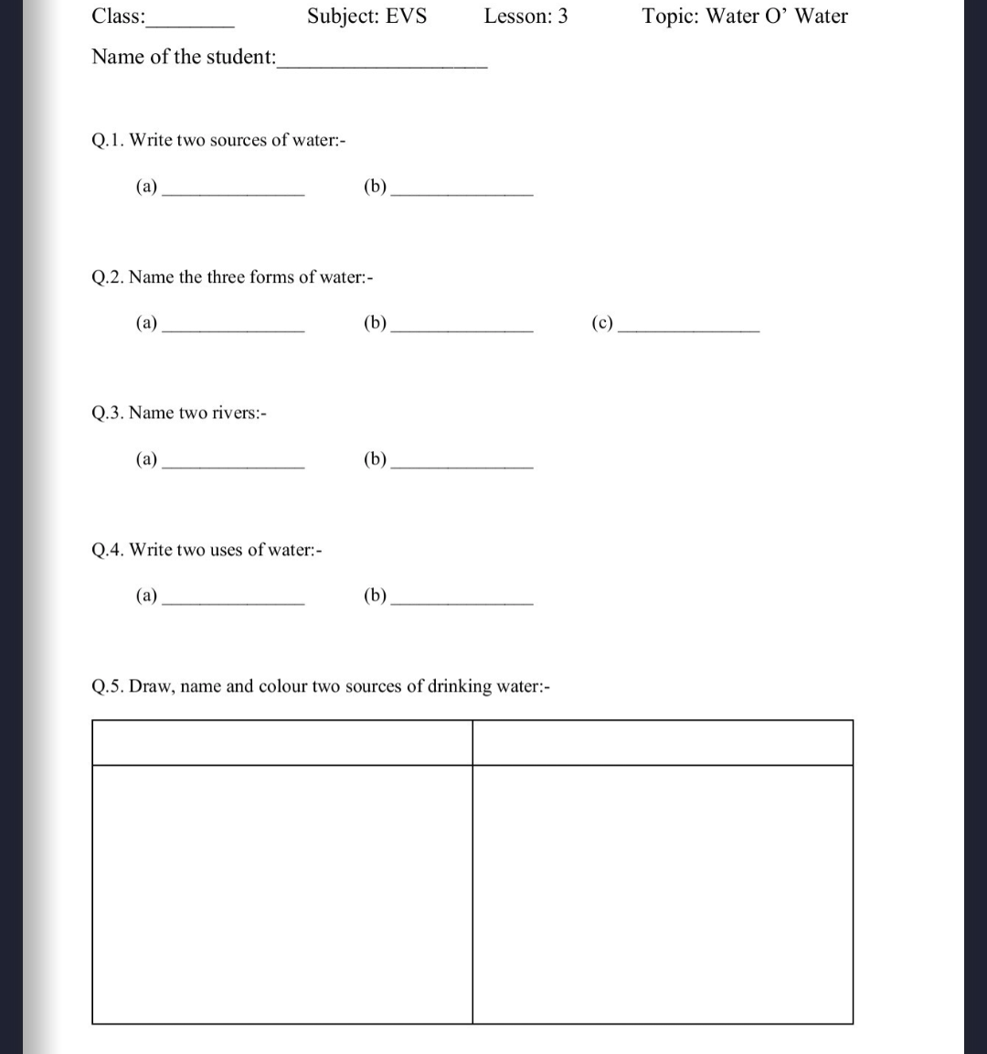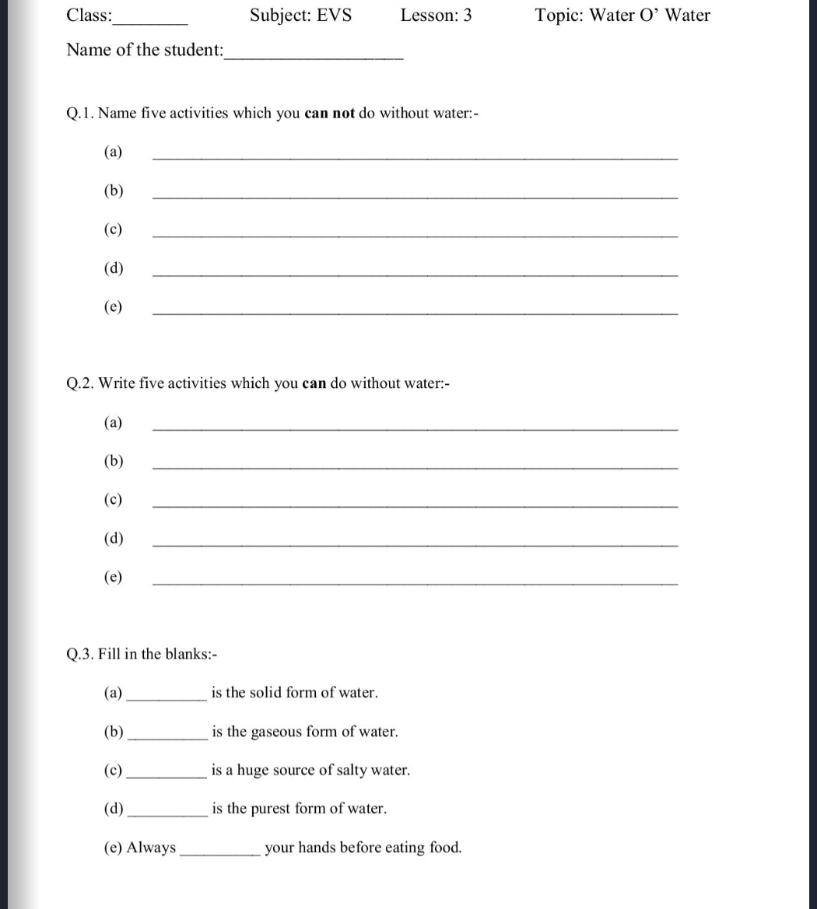

SUB- ENGLISH

Q.1 Write in cursive handwriting 20 page in your english notebook.

Q.2 Write good morning poem and learn it.

Q.3 Write few lines about magic garden and draw picture.

Q.4 Make a project on birds talk and draw /paste some birds picture.

Q.5 Write 10 action words and make its picture.