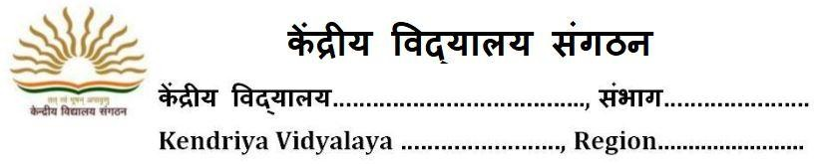
OPTION FORM FOR KV STUDENTS FOR ADMISSION TO CLASS XI (2023-24)
Paste your
Latest Photograph
Reg No Date of Reg.

STREAM CHOICE: Science

- Name of applicant:
- School last Attended:

3. (a) Father’s Name:
  - Occupation :
  - Basic Pay :
Mother’s Name Occupation: Basic Pay :

  - Service Category of Parent as per KVS Admission guidelines
4. Residential Address:
________________________________________________________
________________________________________________________

- Phone /Mobile No Email id

- Category of Applicant (Specify Gen./ SC/ST/OBC(NCL)):

(if SC/ST/OBC(NCL), attach self-attested photocopy of certificates)

- Result of class X (supported by photo copy of mark sheet) CBSE Roll No.

Subject | Marks | Subject | Marks
Hindi |  | Mathematics Standard
Sanskrit |  | Mathematics Basic
English |  | Science
Social Science |  | Total Marks with % | /500 | %

- Aggregate Marks in Science & Math

- Subject Opted Core Subject (1) English

Elective Subject (2) (3)

(4) (5)

- Whether participated in SGFI/KVS National /Regional Sports Meet/Scout/Guide/NCC (if yes, please attach attested photo copies of certificate and give details). Specify the level also

(All taken together Aggregate Marks will not be exceeded by 6%)

Undertaking by the Parents: I hereby undertake that all information given above in the option form is correct and the admission of my ward may be cancelled if any information is found to be false/incorrect/misleading.

Date: Signature of Student Parent‘s Signature with Name

