**SUMMER BREAK HOLIDAY HOME WORK**

**KV CTPP CHHABRA**

**CLASS -5 SUBJECT-EVS**

**Question No-1:**Fill in the blanks:

a) Some animals can hear the __________ sound.

b) Ants leave some __________ on the ground.

c) Some male animals like __________ can recognise their females by their smell.

d) Dogs can make out if another dog has come into their area by the smell of the _________ .

**Question No-2:** ENCIRCLE THE SMELL YOU DON’T LIKE



ENCIRCLE THE SMELL YOU LIKE



**Question No-3:** Animal below want to tell about their super senses help them to complete.

|  |  |
| --- | --- |
|  |  |
|  |  |
|  |  |
|  |  |
|  |  |
|  |  |

**Question No-4:** Identify the following sense organs and write their functions:-

1………………………………………………………………………………………

..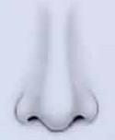

2………………………………………………………………………………………..

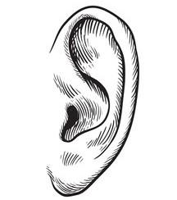

3…………………………………………………………………………………

4. …………………………………………………………………………………………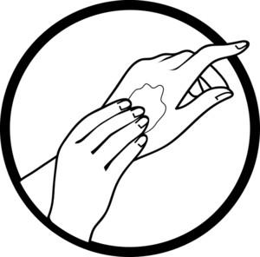

…………………………………………………………………………………………

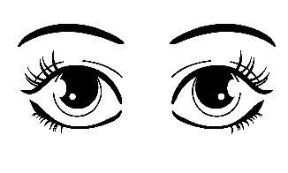

5…………………………………………………………………………………………

…………………………………………………………………………………………………………………………………………………………………………

Answer the following questions:

Q.1. Write the name of a bird which has eyes in front of its head (like in humans).

Ans …………………………………………………………………………………………

…………………………………………………………………………………………

…………………………………………………………………………………………

Q.2. Write the names of some birds which have eyes on either side of the head. What is the size of their eyes as compared to the size of their head?

Ans …………………………………………………………………………………………

…………………………………………………………………………………………

…………………………………………………………………………………………

…………………………………………………………………………………………

Q.3. Write the names of five animals whose ears can be seen.

Ans …………………………………………………………………………………………

…………………………………………………………………………………………

…………………………………………………………………………………………

Q.4. Write the names of some animals whose ears are bigger than our ears.

Ans …………………………………………………………………………………………

…………………………………………………………………………………………

…………………………………………………………………………………………

Q.5. Read the characteristics and identify the animals:-

a) It’s a large animal and its ears are like a fan – ______________________

b) It sleeps in the cold season – ______________________

c) Its roar can be heard upto 3 Km. away ______________________

d) They have fixed eyes, so they move its head very often - _______________

e) These animals give alarm calls by electric signals – __________________

**Q No.- 1.**Write **True** for correct statements and **False** for incorrect statements :-

1. If you throw some sugar on the grounds, the ants never come there. _______
2. Human beings are big threat to Tigers _______

iii) It is allowed to kill animals in National Parks _______

1. Animals can sense the coming of storm, Tsunami, earthquake ________
2. Animals that are awake at night can see things only in Black & White ________

**Q No.- 2.**Tick (√) the correct answer –

a) Lion / Tiger is our national animal.

b) Dinosaurs are extinct / endangered animals.

c) Langur / Giraffe give warning call to other animals at the time of danger.

d) People who kill animals for their body parts are called Poachers / Policemen.

e) Different animals have same / different sleeping hours.

f) Crocodiles are killed for their teeth / skin.

**Q- No. 3** Complete the puzzle using the clues –

The first letter of the animal is mentioned in the puzzle -

**Across** →

1. It has its eyes in front of its head (like humans)
2. This animal is conserved in Gir National Park

iii) It sleeps for 18 Hours a day.

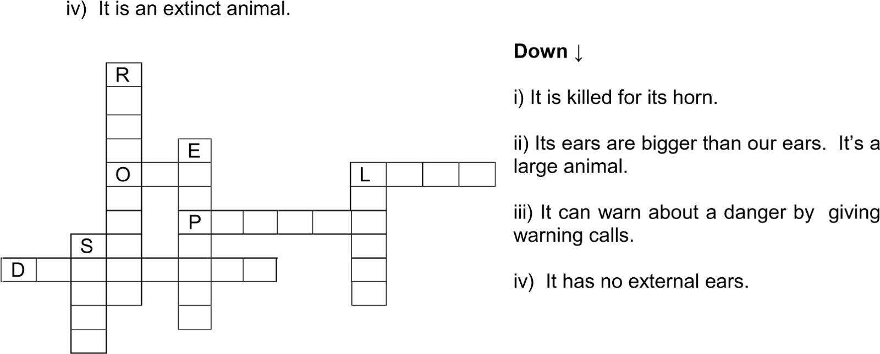

|  |  | | |
| --- | --- | --- | --- |
|  | |
|  |  | |

**Q. No. 5.**Name the animal

a) that takes away your food if you are eating in an open ground. _____________

b) that turns its head to see around. _____________

c) that can see four times as far as we can. _____________

d) that can feel the vibrations on the ground. _____________

e) that can warn about a danger by giving a warning call in the forest. _____________

f) that makes different sounds to give messages to each other in sea. _____________

g) that sleeps in the cold season. _____________

h) that is killed for its skin. _____________

i) that is killed for its tusks. _____________

j) that looks like a bear and spends 17 to 18 hours in sleep. _____________

k) that can finds its female by its smell. _____________

l) that has eyes in front of its head like humans. _____________

**The story of snake charmer**

**Question No-1:**Fill in the blanks:

a) ____________ are the people who catch snakes and make them dance by playing the been.

b) Snakes dance when the ____________ is played.

c) __________ are an important part of Saperas.

d) Snake charmers make ____________ from the plants collected from the forest.

**Question No-2:**Write true or false:

1. All snakes are poisonous. ______________________

2. Snake charmers used to distribute medicines too. ___________________

3. Saperas kill the snakes and sell their skins. ____________________

4. Snakes eat rats which spoil the crops ._____________________

5. Saperas find it very difficult to earn a livelihood now. _________________.

**Question No-3:** a) Which animal is talked about in chapter 2 of your book?.........................................................

b) Do this animal have external years ? ……………………………………….

c) This animal can feel sound/vibration from the ground …………………………..

d) Who all keep these animals for their livelihood?................................................

**Question No-4:**Answer the following questions:

a)Who are Kalbeliyas ?

………………………………………………………………………………………………………………………………………………………………………………………………………………………………………………………………………………………………………………………………………................………………………………………………………

b)Recognise this musical instrument?

Who uses this instrument?

For what purpose it is used?

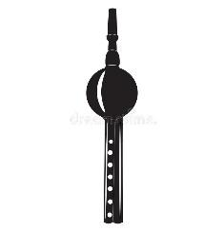

…………………………………………………………………………………………………………………………………………………………………………………………………………………………………………………………………………………………………………………………………………………………………................……………………………

c)What are fangs ?

……………………………………………………………………………………………………………………………………………………………………………………………………………………………………………………………………………………………………………………………………………………………...........

**Question No-5:**How did the snake charmers helped the people of the villages?

Ans …………………………………………………………………………………………………………….. …………………….. ... . …………………………..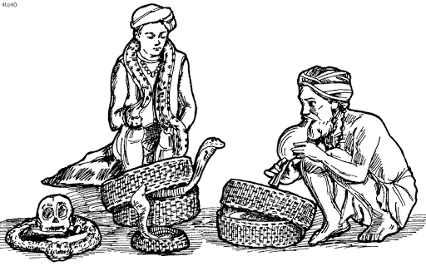

|  | |
| --- | --- |
|  |

**Question No-6:** Give two examples of animals used by man for his livelihood. How are they used?

Ans ………………………………………………………………………………………………………………………………………………………………………

**Question No-7:**Name two ways by which the Government has taken steps to protect the wild life in India.

Ans …………………………………………………………………………………………………

………………………………………………………………………….....………………………………..

**Question No-8:**Fill in the blanks:

a) Some snake bites cause ____________ on the spot.

b) A snake has ____________ hollow teeth.

c) The poisonous teeth of snakes are called ____________.   
d) Most of the snakes are not ____________.

e) Only ____________ types of snakes are poisonous in our country.

f) There is a ____________ of poison in a snake’s mouth.

g) The medicine for a snake bite is made from the snake’s __________.

h) Kalbeliya dance has movements similar to the dance of a __________.

i) The musical instruments been, tumba and khanjiri used by Kalbeliyas except dhol are made from dried ____________.

j) The government has made a law that no one can catch snakes/wild animals to ____________ them from being killed.

k) Snake charmers can know the type of snake from the marks of its_____________.

**FROM TASTING TO DIGESTING**

1.Draw five food items that you can identify by smelling’.

2 Classify the following food items according to their taste.

Potato chips, lemon, gulab jamun, jaggery, bitter gourd, lime juice, coffee, Pasta.

| SWEET | SALTY | BITTER | SOUR |
| --- | --- | --- | --- |
|  |  |  |  |
|  |  |  |  |

3.Label the taste buds of the tongue.

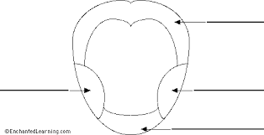

1)What is the work of saliva in our mouth?

----------------------------------------------------------------------------------------------------------

2)Why should we chew our food very well?

—-----------------------------------------------------------------------------------------------------------

3) What happens when you eat food?

----------------------------------------------------------------------------------------------------------

4)Write the names of the given organs in the diagram.

FOOD PIPE , MOUTH , SMALL INTESTINE , STOMACH , LARGE INTESTINE

